LAB ONE–Introduction

In this lab you will get familiar with the simulation environment, GNS3, and other software packages such as VirtualBox, IPterm, etc., that all form part of the complete lab environment. You will need to download all the appropriate software on your computer/laptop (PCs, Macs) to work on the labs.

# PART1. GNS3 Installation & Settings

In this first part of the lab, you will learn how to install and configure GNS3 VM, the network simulator software that will run on a Virtual Machine.

## Exercise 1(A). Installation and Initiation of VIrtualBox and GNS3

System Requirements

* + Windows 7 or higher with an Internet connection
  + Mac OS X 10.9 or above with an Internet connection

**Note: Click on choices in figures as shown in red rectangles**.

1. Download [VirtualBox](https://www.virtualbox.org/wiki/Downloads) for your platform (Windows, Mac OS X):

https://www.virtualbox.org/wiki/Downloads.

Follow the installation instructions as given on the website (use default settings).

1. Upon successful installation, you should see the following screen. Close the window.

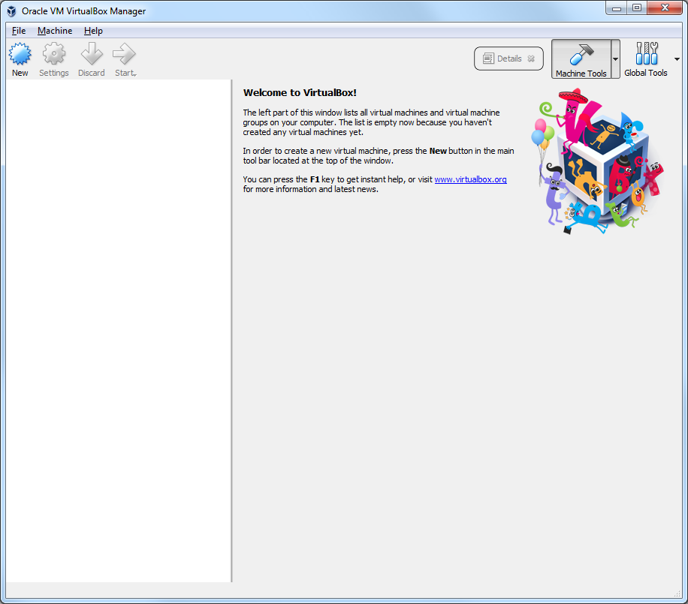

Figure 1.1

1. Open Host Network Manager window by opening the “File” menu and selecting “Host Network Manager” or by pressing the keyboard shortcut “Ctrl + W” for Windows or “Command + W” for Mac OSX. For older versions of VirtualBox, press a shortcut key “Ctrl + ,” for Windows or “Command + ,” for Mac OSX.

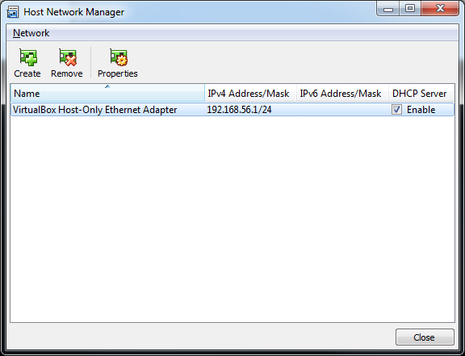

Figure 1.2

1. If you see a host-only adapter already in the window (as shown in Figure 1.2), you can skip this step. Otherwise, create a Host-only network by pressing “Create” button in the menu.
2. Make sure the DHCP Server Enable option is checked. Now close the Host Network Manager window.
3. Click Properties icon in the menu. And check if the adapter ‘s IP address is set to 192.168.56.1, and the netmask is set to 255.255.255.0 in Adapter tab as shown in Figure 1.3 under the Adapter tab.
4. Then click on the DHCP server tab,, check if “Enable Server” option is enabled in DHCP Server tab, 192.168.56.100 is set for Server Address, 255.255.255.0 is set for Server Mask, 192.168.56.101 is set for Lower Address Bound, and 192.168.56.254 is set for Upper Address Bound as shown in Figure 1.4.

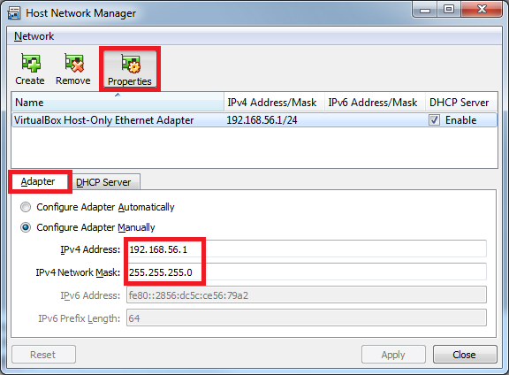

Figure 1.3

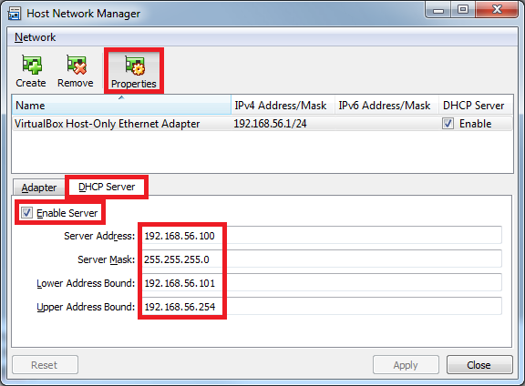

Figure 1.4

1. Download GNS3 (sample download window view shown below):

<https://www.gns3.com/software>[1]

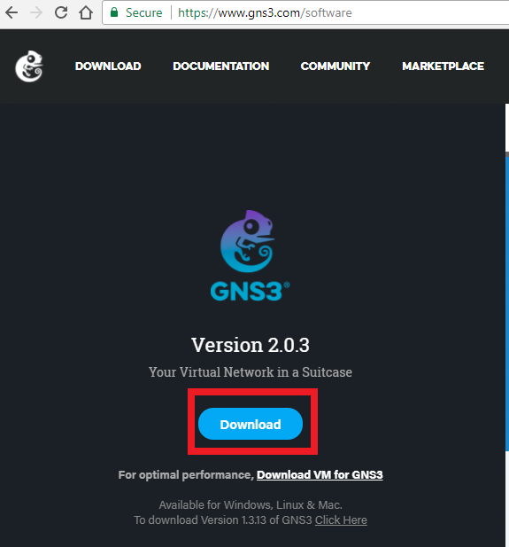

Figure 1.5

1. Install the downloaded GNS3 software. **Note**:
   * For **Windows**, when prompted for “Choose Components”, please **uncheck** “SolarWinds Response Time Viewer**”** as shown high-lighted in Figure 1.6 below,and click No for Toolset as shown in Figure 1.7.

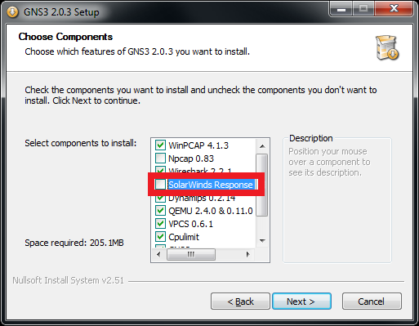

Figure 1.6

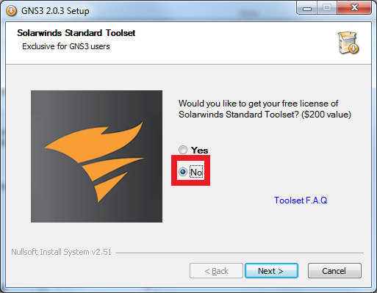

Figure 1.7

1. Finish the installation process[2].

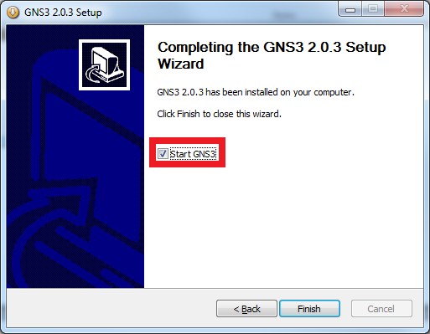

Figure 1.8

1. The GNS3 simulator will open automatically if Start GNS3 is checked (see Figure 1.8 above).
2. You will see the following Setup Wizard screen (Figure 1.9). Click "Next". Please note that you can always restart this setup wizard by opening Help menu in GNS3 and selecting “Setup Wizard”.

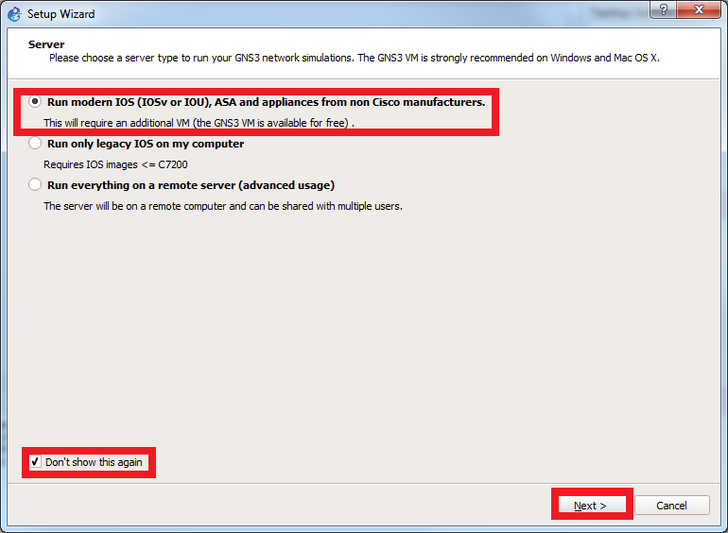

Figure 1.9

1. Select 192.168.56.1 for “Host binding” option and click “Next” as shown in Figure 1.10 below.

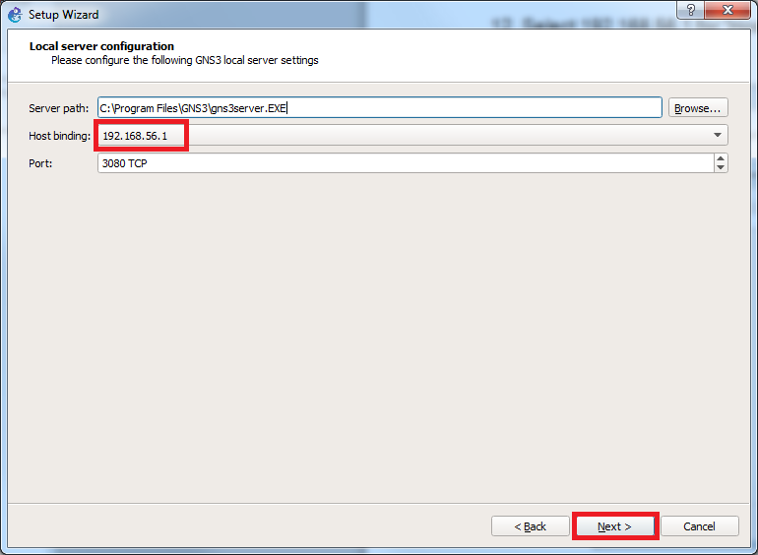

Figure 1.10

1. Installation in progress, wait till DONE. Figure 1.11.

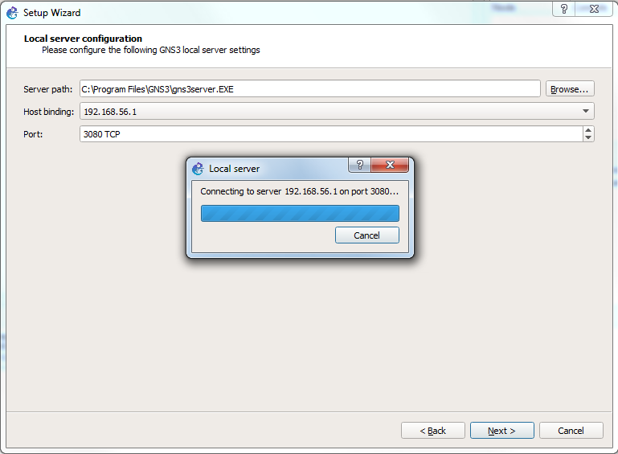

Figure 1.11

1. Installation done. Click “Next”.

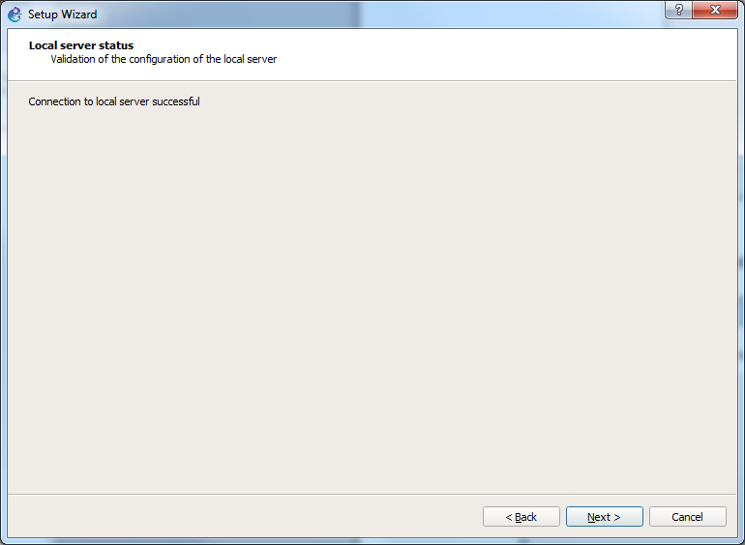

Figure 1.12

1. You will see a screen as shown in Figure 1.13. Click OK to proceed to the next screen.

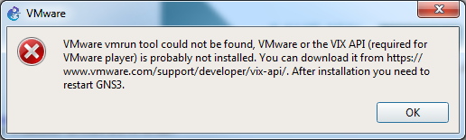

Figure 1.13

1. Check “VirtualBox” as shown in Figure 1.14. You will see a screen pop up as shown in Figure 1.15. Click “OK”. Then you will see another screen with an error message as shown in Figure 1.16. Click “OK”.

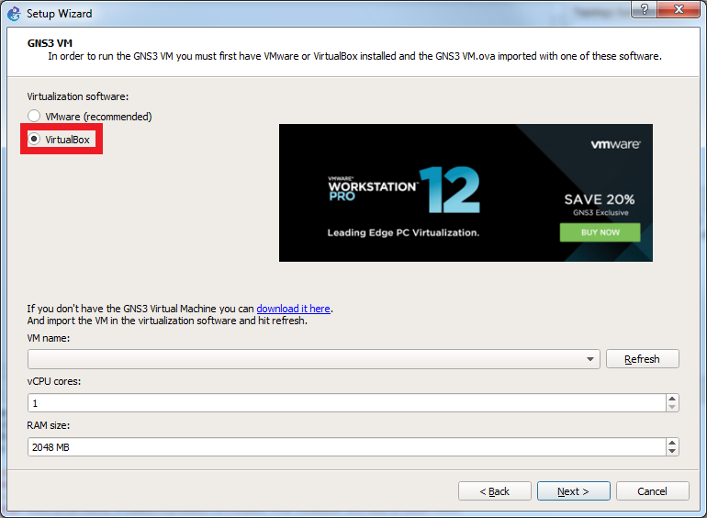

Figure 1.14

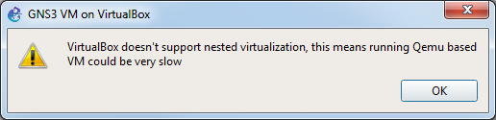

Figure 1.15

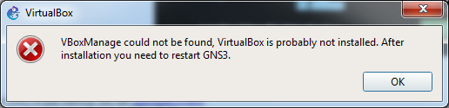

Figure 1.16

1. Click the link “download it here” as shown in Figure 1.17. Your web browser will automatically download the GSN3 VM file “GNS3.VM.VirtualBox.2.x.x.zip”.

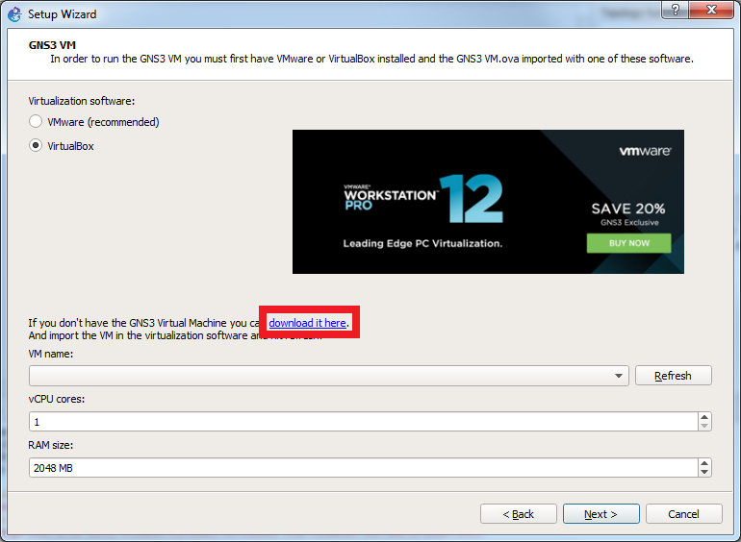

Figure 1.17

1. NOTE: Do not close the setup wizard screen Figure 1.17. You will come back to this screen after installation of GNS3 VM on VirtualBox.
2. Go to your default **Downloads folder** on your computer and extract the “GNS3 VM.ova” file from the downloaded GNS3 VM file “GNS3.VM.VirtualBox.2.x.x.zip” as shown in Figure 1.18. Please note that the version of the GNS3 VM should match the version of GNS3.

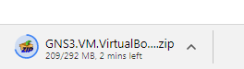

Figure 1.18

1. After you have extracted the ".ova" file, open VirtualBox (recall you installed it in the first step of this lab) and click on File menu and select “Import Appliance” as shown in Figure 1.19.

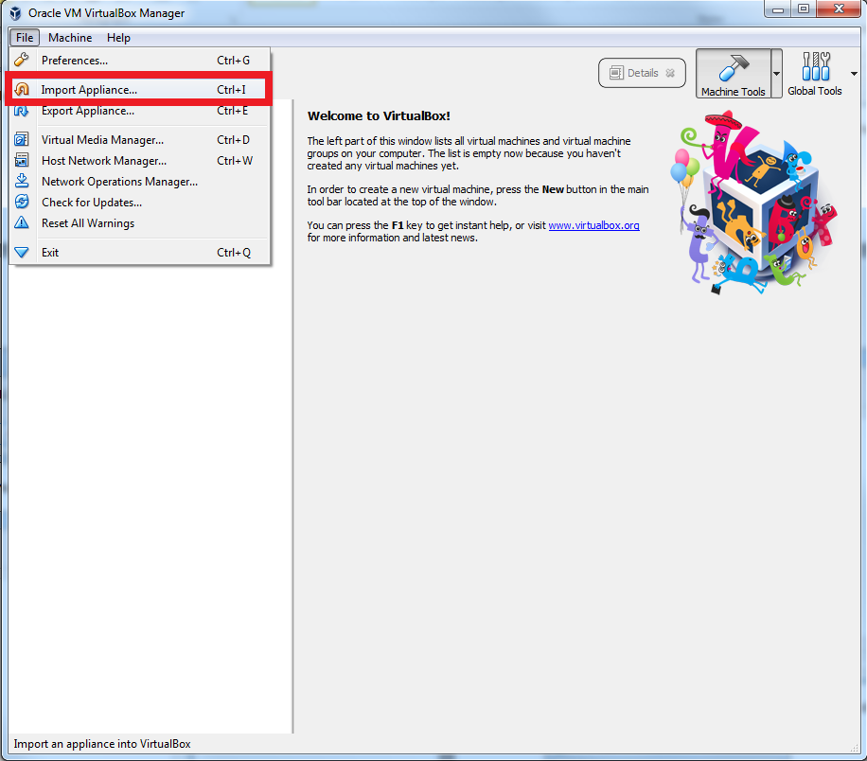

Figure 1.19

1. Select the “GNS3 VM.ova” file that you just downloaded and extracted. The example below shows the file in a sample (on a Windows computer) **Downloads folder**. Click “Next”.

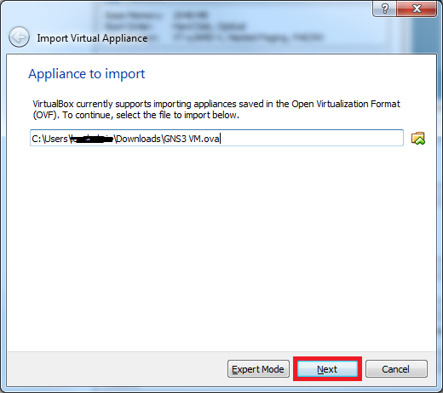

Figure 1.20

1. Click “Import”. Wait for the process to be completed.

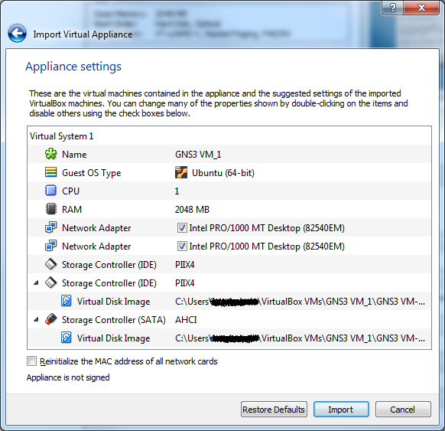

Figure 1.21

1. You should see the following screen once import is completed.

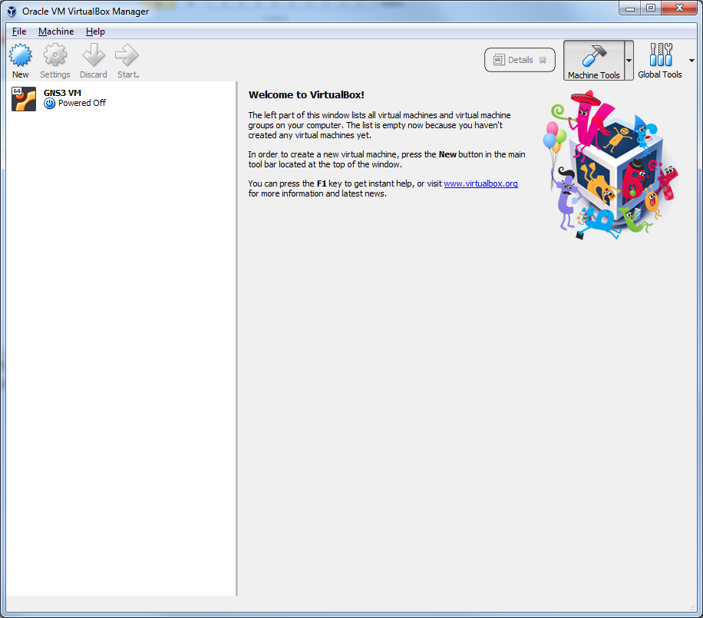

Figure 1.22

1. Click "Settings" Icon as shown in Figure 1.23.

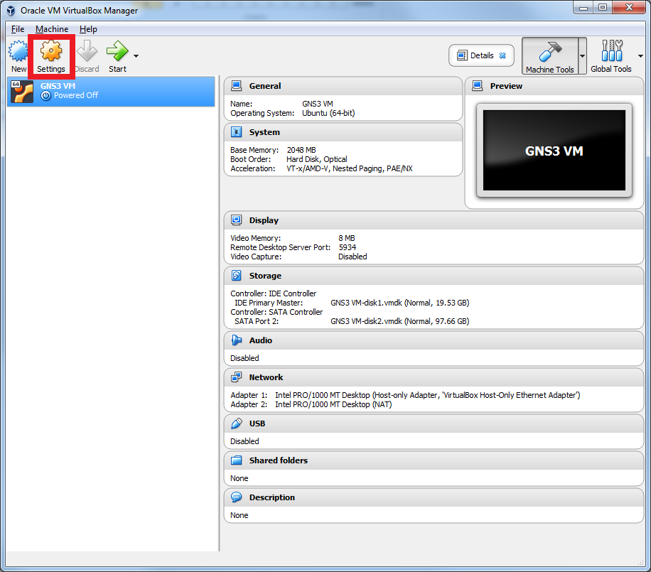

Figure 1.23

1. Select “Network” and make sure the “Enable Network Adapter” option is checked for Adapter 1 as shown in Figure 1.24. Also check if a Host-Only Ethernet Adapter is assigned as shown in Figure 1.24. If any Host-Only adapter option is empty, then follow the previous steps 3, 4 and 5 to add a host-only adapter. Then, select the created adapter.

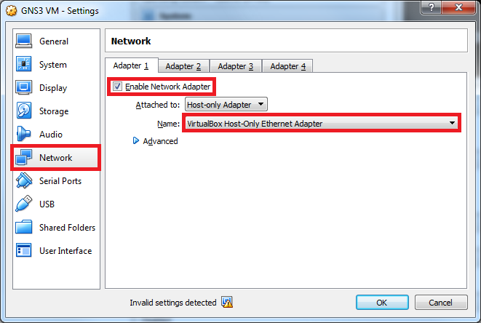

Figure 1.24

1. Expand "Advanced" as shown below.

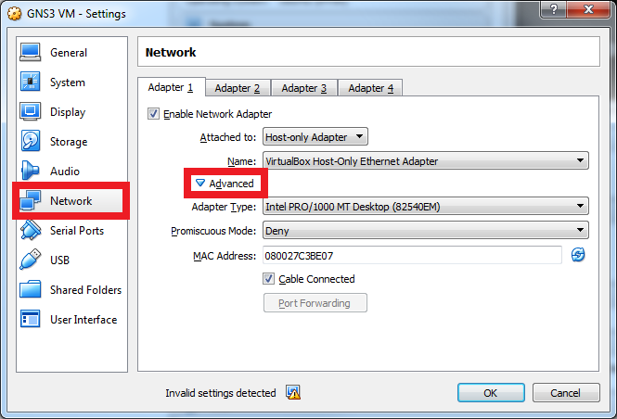

Figure 1.25

1. Choose Allow All under “Promiscuous Mode” as shown in Figure 1.26.

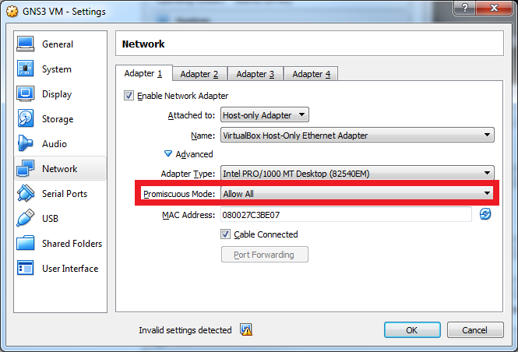

Figure 1.26

1. Select Adapter 2 option and make sure if the “Enable Network Adapter” is checked for Adapter2. Also check if the adapter is attached to “NAT” as shown in Figure 1.27.

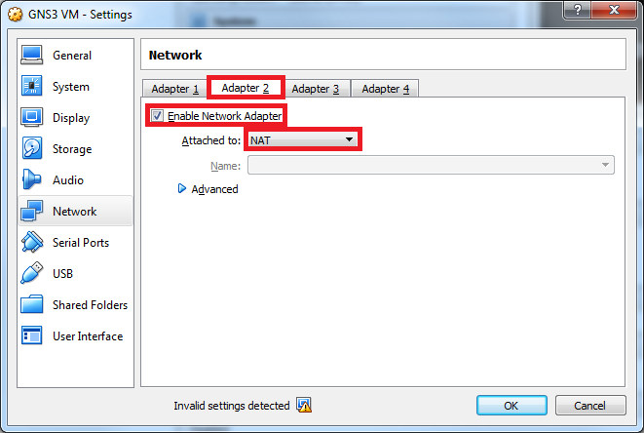

Figure 1.27

1. Return to the GNS3 Setup wizard window that you left earlier (Figure 1.17) and click “Refresh”.

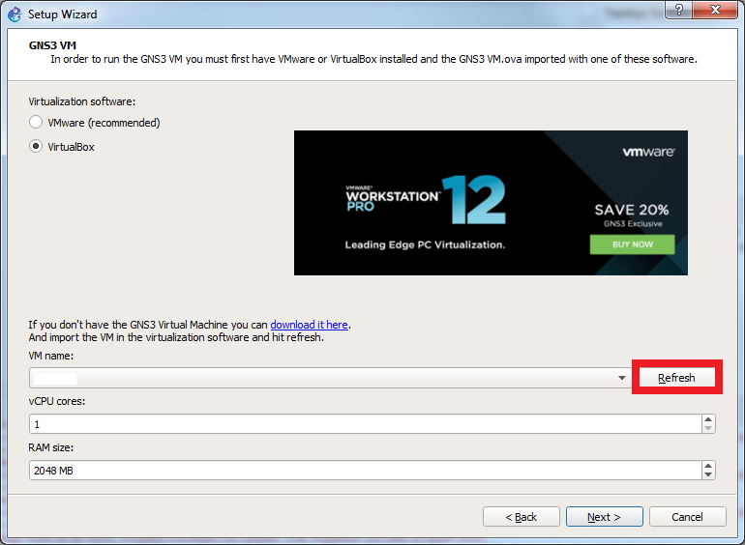

Figure 1.28

1. You should see the VM name field as shown in the red box. Click "Next".

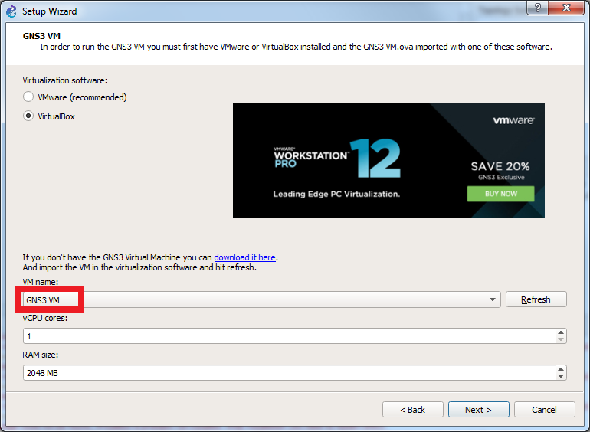

Figure 1.29

1. Setup wizard will appear as shown previously in Figure 1.28 and GNS VM will start "running" on Virtual Box as shown in Figure 1.31.

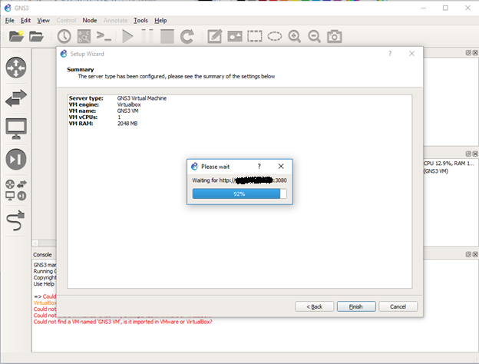

Figure 1.30

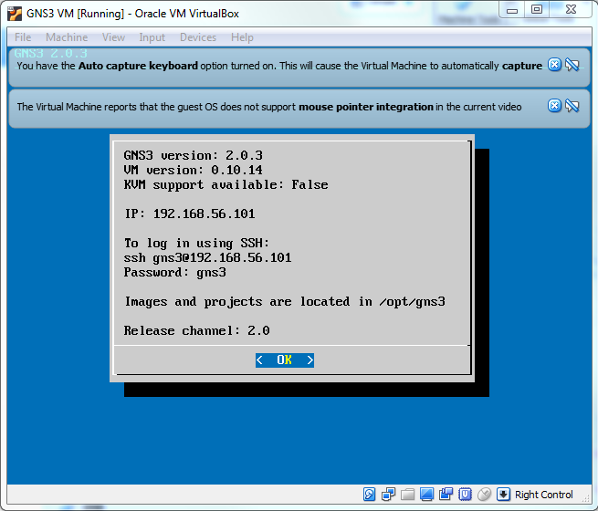

Figure 1.31

1. You can now click "Finish" on the Setup Wizard screen.

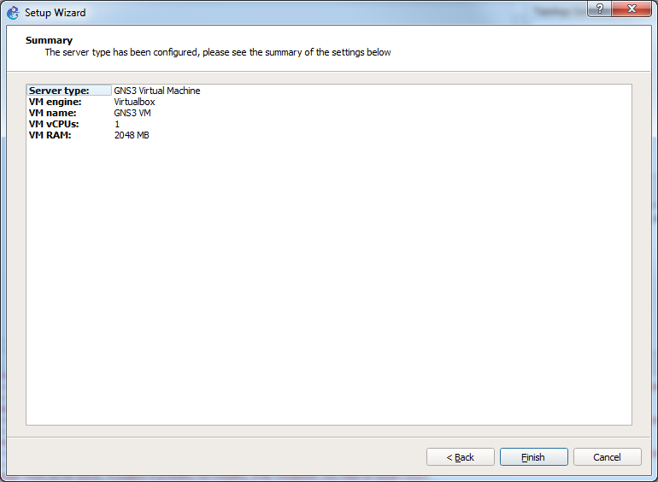

Figure 1.32

1. Click "Cancel" in New appliance template screen.

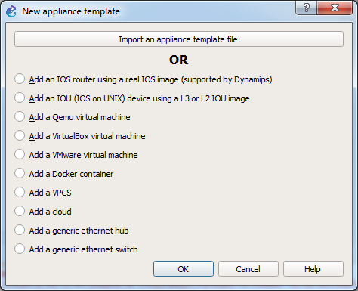

Figure 1.33

1. Click "Cancel" in Project screen.

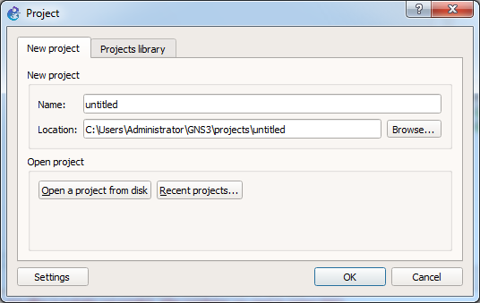

Figure 1.34

1. You should see the following GNS3 screen. Ignore the error messages that appear on the Console window.

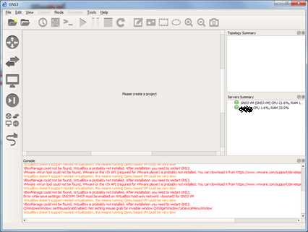

Figure 1.35

1. If 1) the GNS3 VM’s status indicator is in red in the Server Summary section, 2) the GNS3 VM’s screen does not change from black screen and 3) you observe GNU GRUB screen in the GNS3 VM’s booting sequence, then try to check if Hardware Virtualization is enabled from BIOS. Please note that the steps to enable Hardware Virtualization in BIOS could vary depending on the computer manufacturer and the computer models. The sample steps are given in the [link](https://docs-old.fedoraproject.org/en-US/Fedora/13/html/Virtualization_Guide/sect-Virtualization-Troubleshooting-Enabling_Intel_VT_and_AMD_V_virtualization_hardware_extensions_in_BIOS.html).
2. If the GNS3 VM’s status indicator is in grey or in red in the Server Summary section, If the GNS3 VM’s screen is similar to Figure 1.31 then try to make sure if the DHCP option is checked in the host-only adapter and adapter is correctly set up as shown in the Figure 1.2, Figure 1.3, and Figure 1.4. If not then, quit GNS3 and delete GNS3 VM from VirtualBox. Follow step 3 through 6. Then, import GNS3 VM following step 20 through 28. Try to open GNS3 again and check the indicator becomes in green after a while.
3. If the status indicator of GNS3 VM is not in green, then quit GNS3 (GNS3 VM will also quit) and restart the GNS3 VM from Virtual Box manually (see figure 1.23). Wait until you see the GNS3 VM screen as shown in Figure 1.31. Then, start the GNS3 from the desktop.
4. If the issue does not go away, try to install VMWare and run the GNS3 VM on the VMWare instead. The instruction video is given in this [link](https://www.youtube.com/watch?v=_EblCywJqBs&t=436s). Please check the version compatibility of VMWare VIX-API to the version of VMWare Workstation Player or VMWare Fusion. For example, the VIX-API 1.15 is compatible to VMWare Fusion 8 or to VMWare Workstation Player 12.
5. If you want to restart the setup wizard from the beginning, open Help menu in GNS3 and select “Setup Wizard”.
6. If the server indicators in the Server Summary are in green as shown in Figure 1.35, GNS3 software installation is done. **Quit** GNS3.

## Exercise 1(B). Importing Cisco Router IOS image into GNS3

1. Download c3640-a3js-mz.124-19b.bin
2. Open GNS3 on your computer. You should see a screen as shown in Figure 1.36.

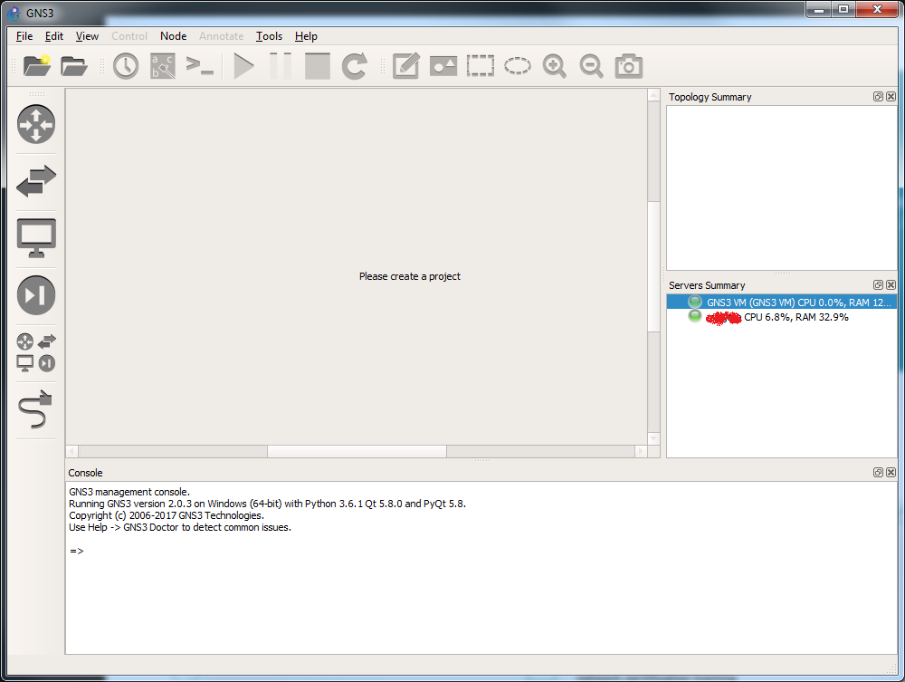

Figure 1.36

1. Go to:

* **Windows**: Edit -> Preferences
* **Mac**: GNS3 -> Preferences

1. In the left-hand pane, click on the arrow next to “Dynamips”, then click on the sub-menu “IOS routers” and click “New” as shown in Figure 1.37.

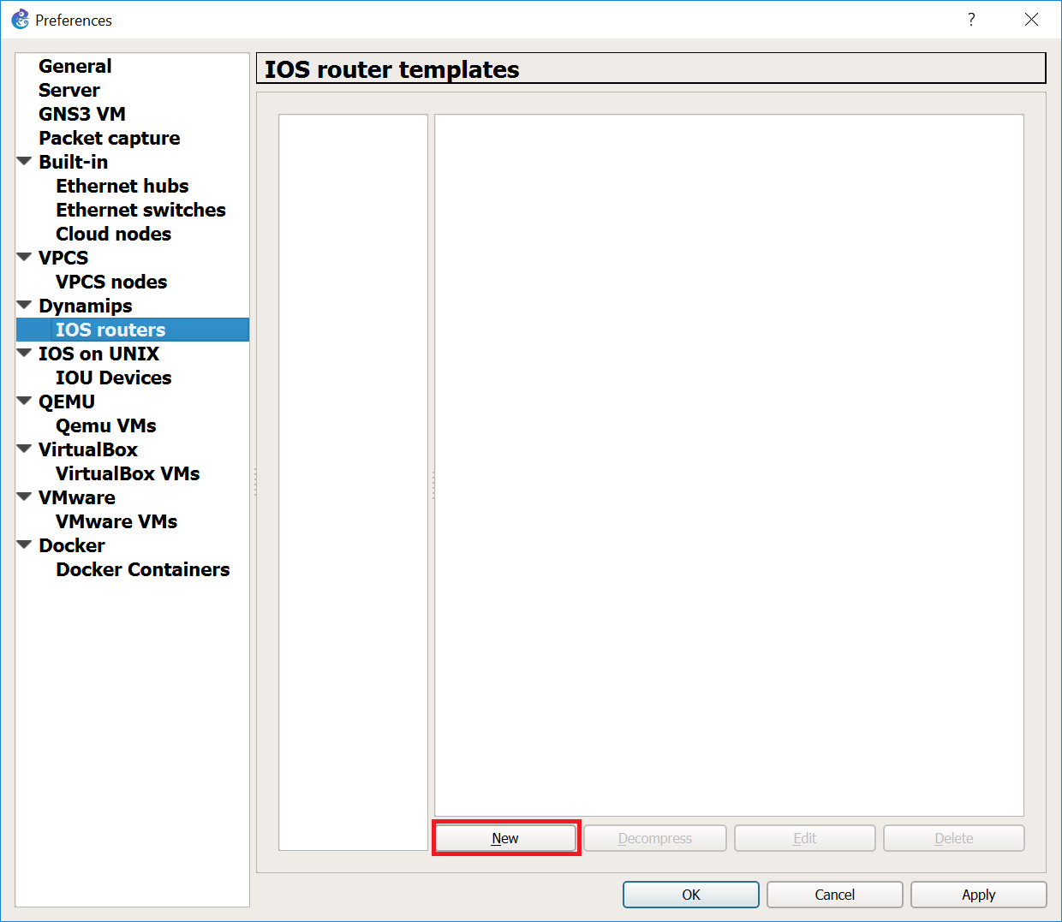

Figure 1.37 Creating router template

1. Select “Run this IOS router on my local computer” and Click “Next” as shown in Figure 1.38.

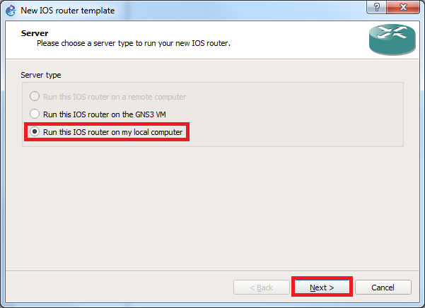

Figure 1.38

1. Then click on "Browse" to select the Cisco IOS image on your computer “c3640-ik9o3s-mz124-13.bin’’. Click “Next”.
2. Edit “Name” as c3640, select the "Platform" as c3600 and "Chassis" as 3640 as shown in Figure 1.39 below.

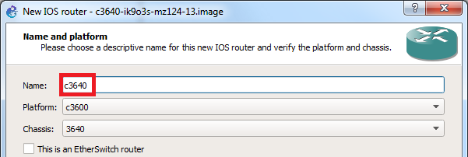

Figure 1.39 Cisco router selection

1. Click "Next" and check to see if memory size is set to 128MiB, if not, set it to that size. Please note that the memory size setting is strict, i.e., **not** optional. Setting memory to more than 128MiB can cause a problem when you are running large network configurations with several routers.
2. Click "Next" to get to screen for "Network adapters" selection as shown in Figure 1.40 below. Choose NM-1FE-TX from the dropdown menu for slot 0 through slot 3.

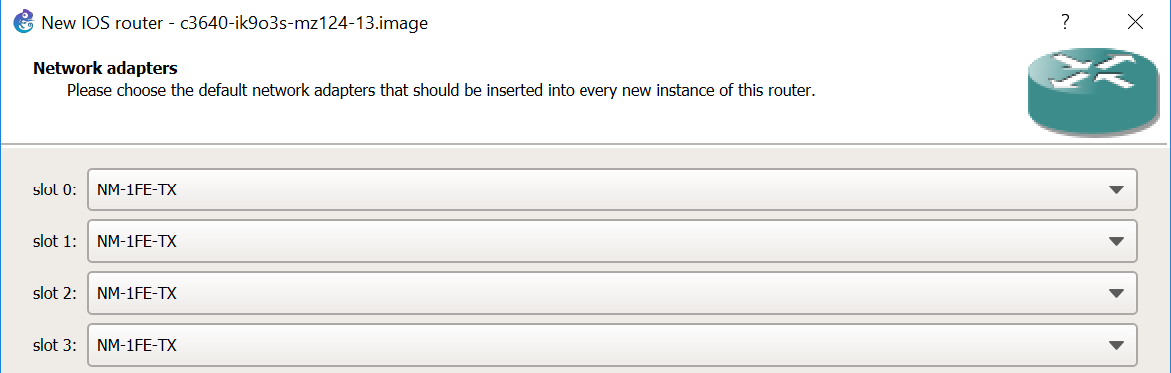

Figure 1.40 Cisco router’s WIC module setup

1. Click “Next”. Find the Idle PC value by clicking on Idle-PC finder. Please note that you can skip this step if the Idle-PC finder fails more than 2 times. Click “Finish.”
2. After finishing the setup, you should see the following screen as shown in Figure 1.41 below. Click "Apply", then click "OK".

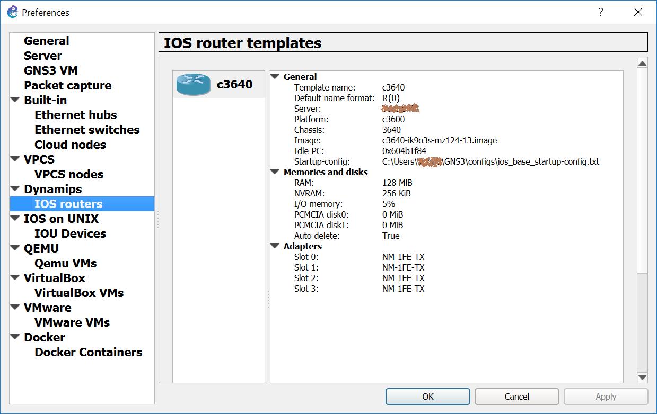

Figure 1.41 Cisco router preferences

1. In the GNS3 console window that appears (shown below in Figure 1.42), click on the “folder icon” in upper left hand corner or choose “New blank project” from “File” menu[3].

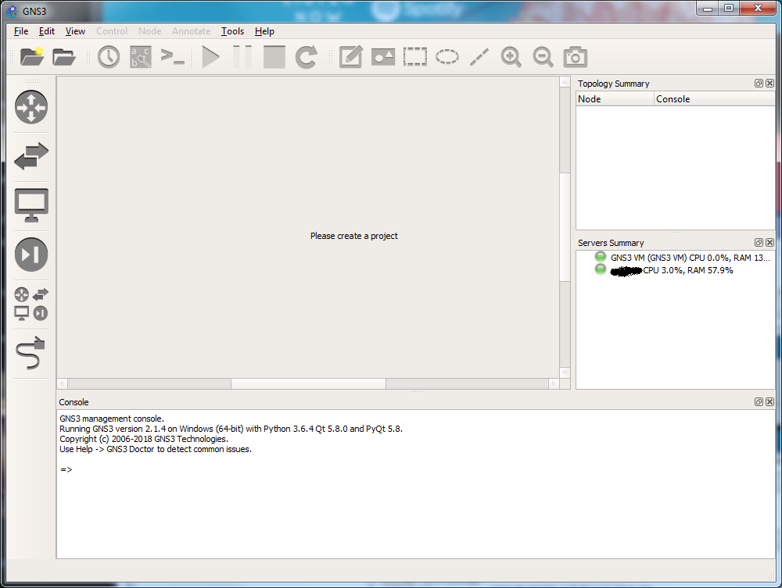

Figure 1.42 GNS3 startup screen

1. Click on "Browse All Devices" icon, (5th icon on the left-hand side shown in red rectangle)) and select “Installed appliances”, to browse all possible network devices. Select c3640 and drag it to the empty space (project pane) to the right of the devices window as shown in Figure 1.43. Please note that if the c3640 does not appear in the installed appliances list as shown in Figure 1.43, then quit GNS3 and open GNS3 again. Then the icon should appear.

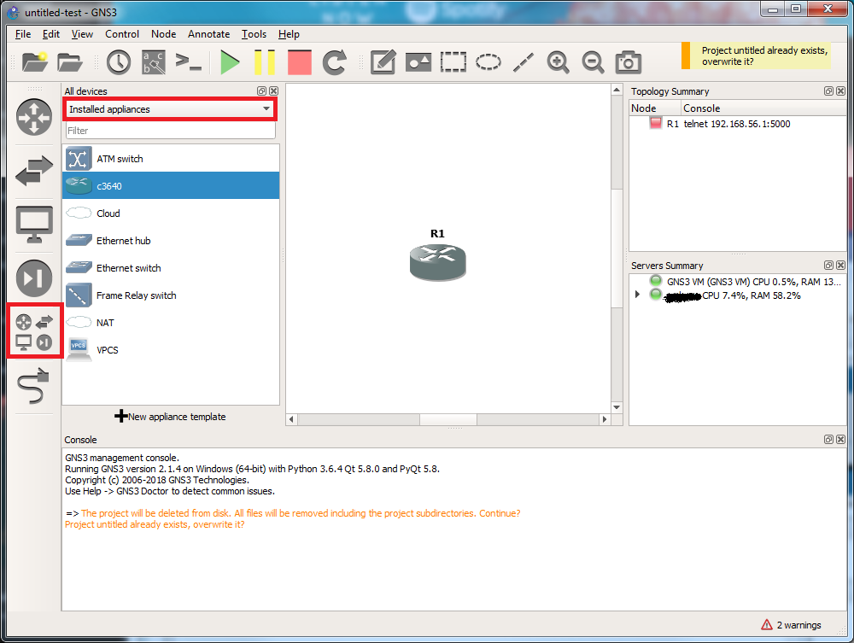

Figure 1.43 How to add a router to the GNS3 "Project" pane

1. Right-click on **R1** and choose "Start".
2. Right click on **R1** again and select “Auto Idle-PC”. The system will choose the best value. It is recommended that you do this every time you add a router to a project. It is also recommended that you do this when starting a saved project too.
3. Check CPU load of your system[4]. If > 50%, repeat step 14 for each router and recheck. If it does not drop, quit GNS3. Restart GNS3 and repeat steps 11 - 15 if creating a new project, or repeat steps 13-15 on a saved project after starting each router.
4. Right-click on **R1** and choose "Console". Console window will open. You maybe prompted in console window to press "Return" key to get the prompt line.
5. You have finished the first step in running GNS3. Congratulations!!!!
6. Stop all running devices by clicking the “Stop All Nodes” button (red square button on upper tool bar) in GNS3. Quit GNS3.

## Exercise 1(C). Importing ipterm into GNS3 VM

1. First you will need to download the ipterm GNS appliance from the GNS3 Market Place as shown in Figure 1.44 and Figure 1.45 using the following link:

<https://www.gns3.com/marketplace/appliances>

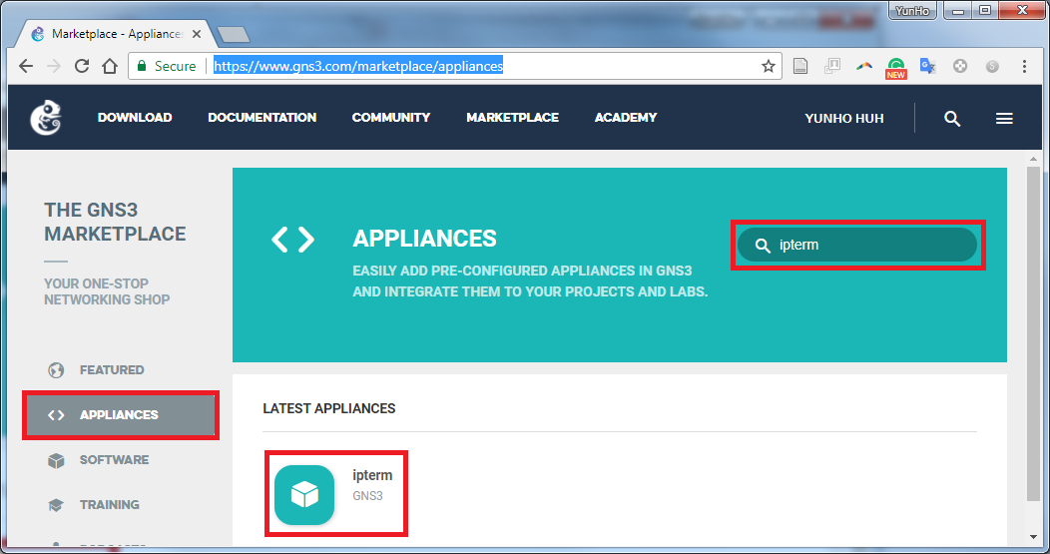

Figure 1.44

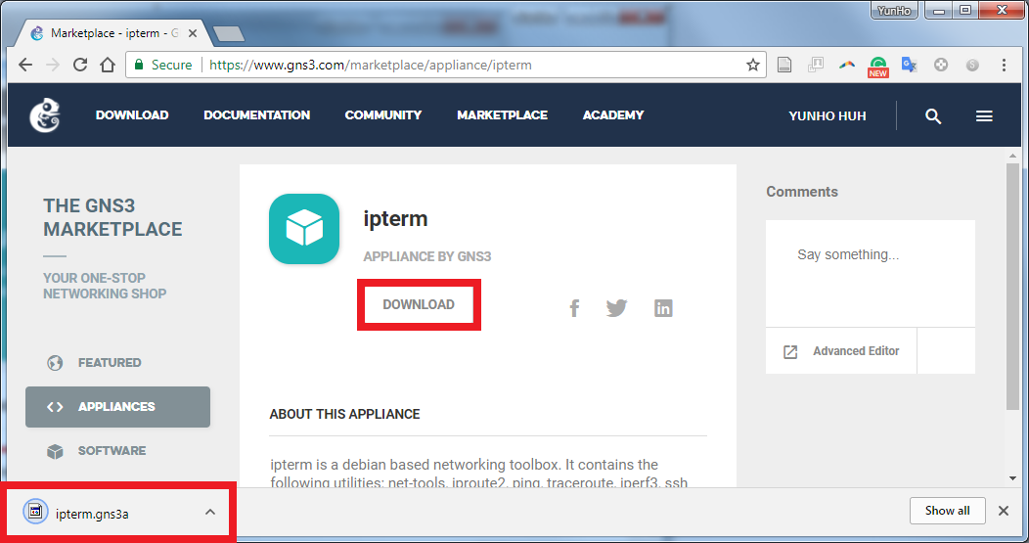

Figure 1.45

1. Open File menu and select Import appliance as shown in Figure 1.46.

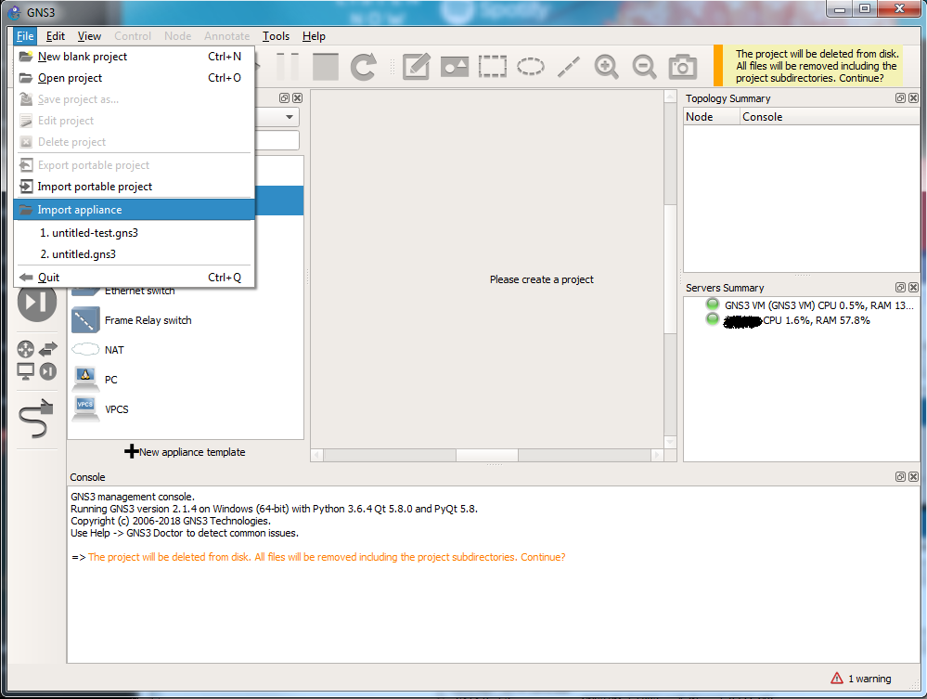

Figure 1.46

1. Select the downloaded impterm.gns3a file and click Open.
2. The following screens will appear. Click "Next" all the way through Figure 1.49 and click Finish as shown in Figure 1.50. Then you will see the message box shown in Figure 1.51. Click OK.

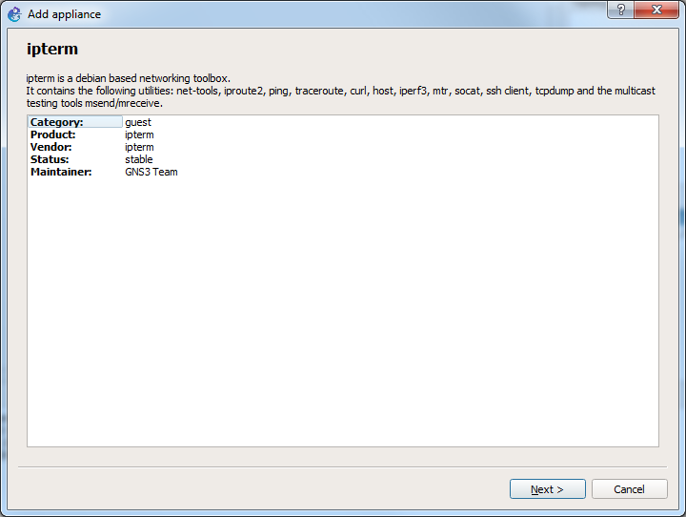

Figure 1.47

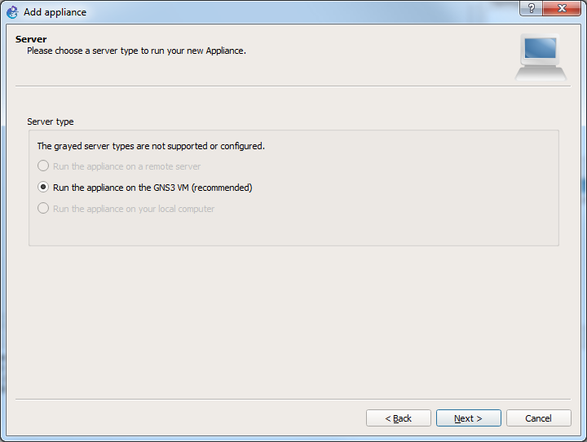

Figure 1.48

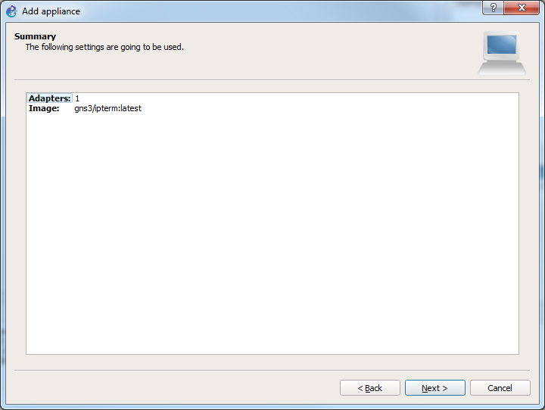

Figure 1.49

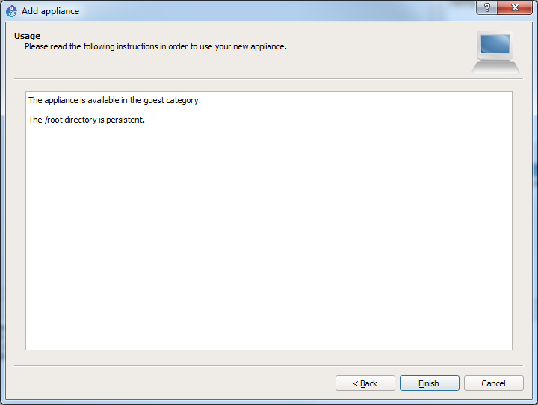 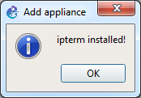

Figure 1.50 Figure 1.51

1. When completed, select “Browse all devices” icon on the left side menu of GNS3, then you should see the ipterm in the “installed appliances” list. If the ipterm icon does not appear in the list after step 4, quit GNS3 and restart GNS3 again. The ipterm icon should appear in the appliances list as shown in Figure 1.52.

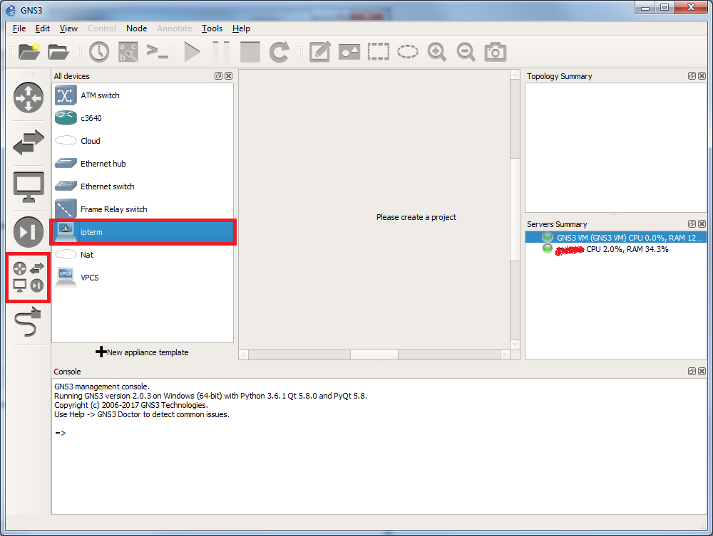

Figure 1.52

1. Rename ipterm to PC using the following steps and remove “-“ from Default name format in Figure 1.55.

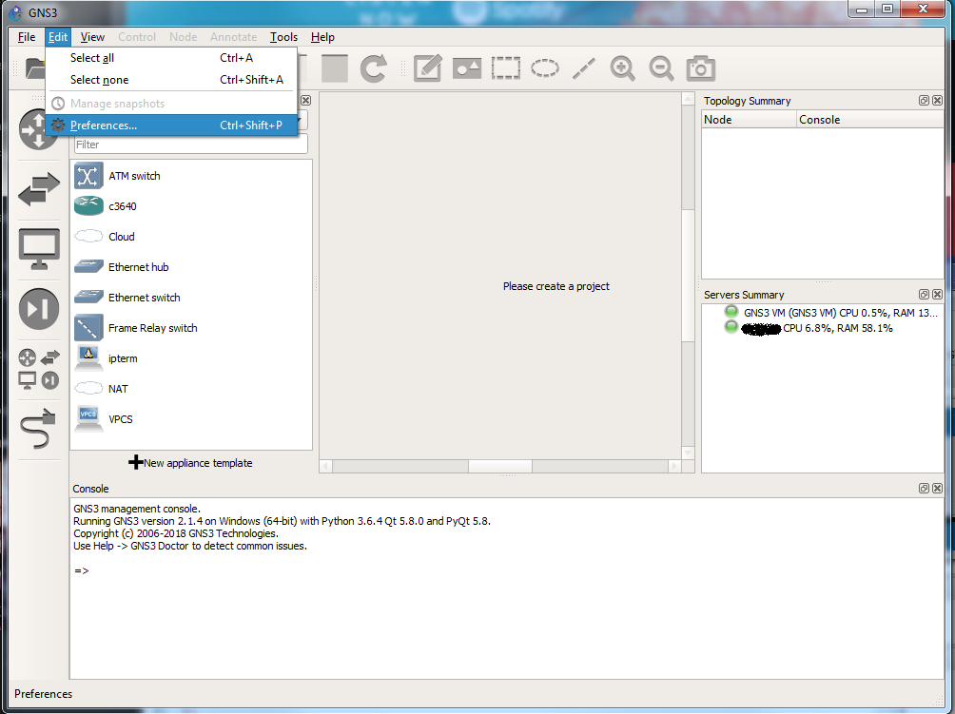

Figure 1.53

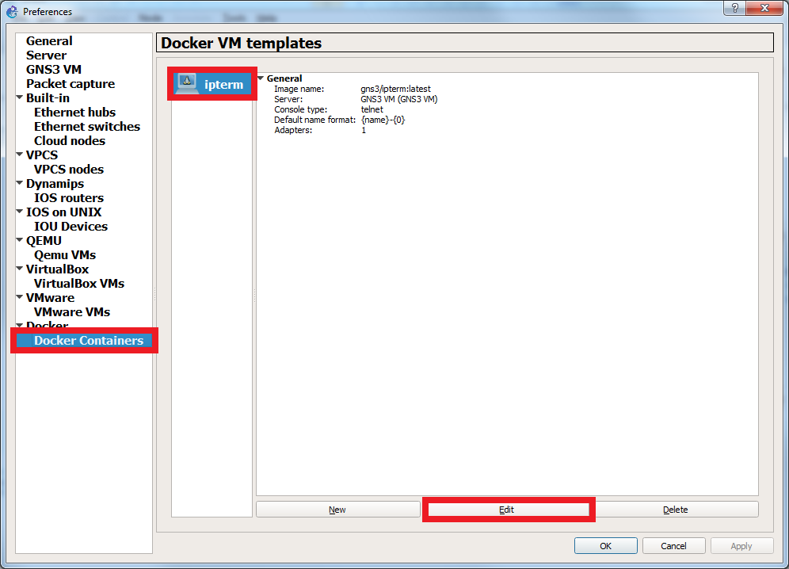

Figure 1.54

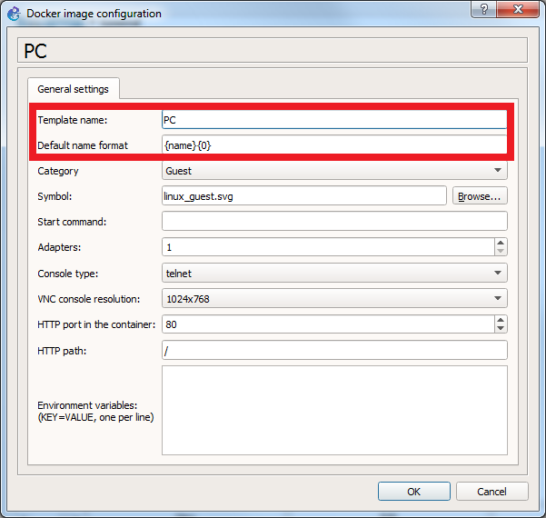

Figure 1.55

1. You will see the following screens. Click OK.

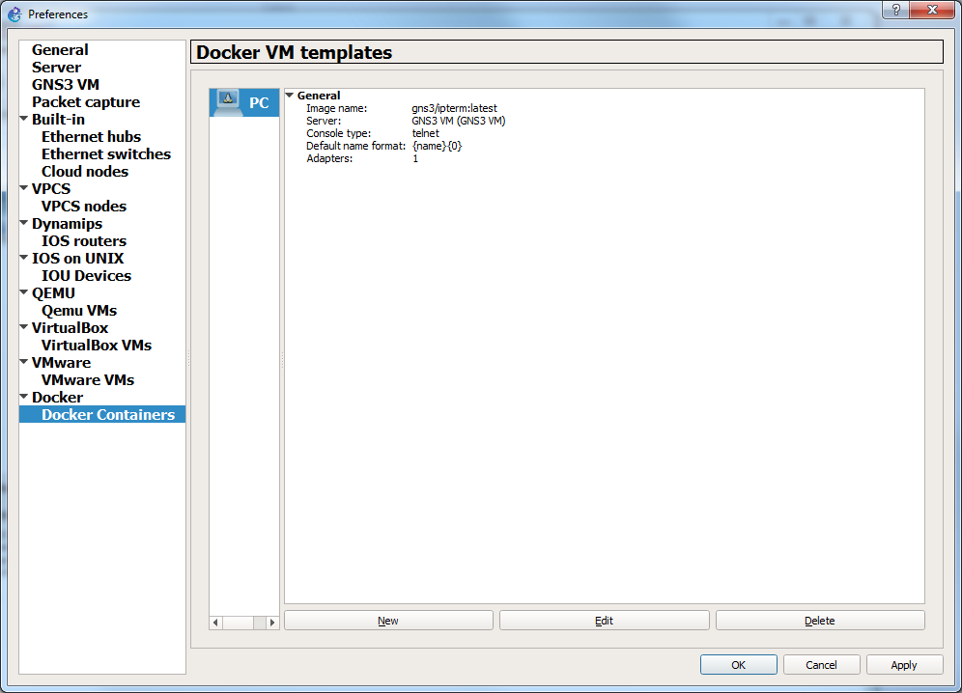

Figure 1.56

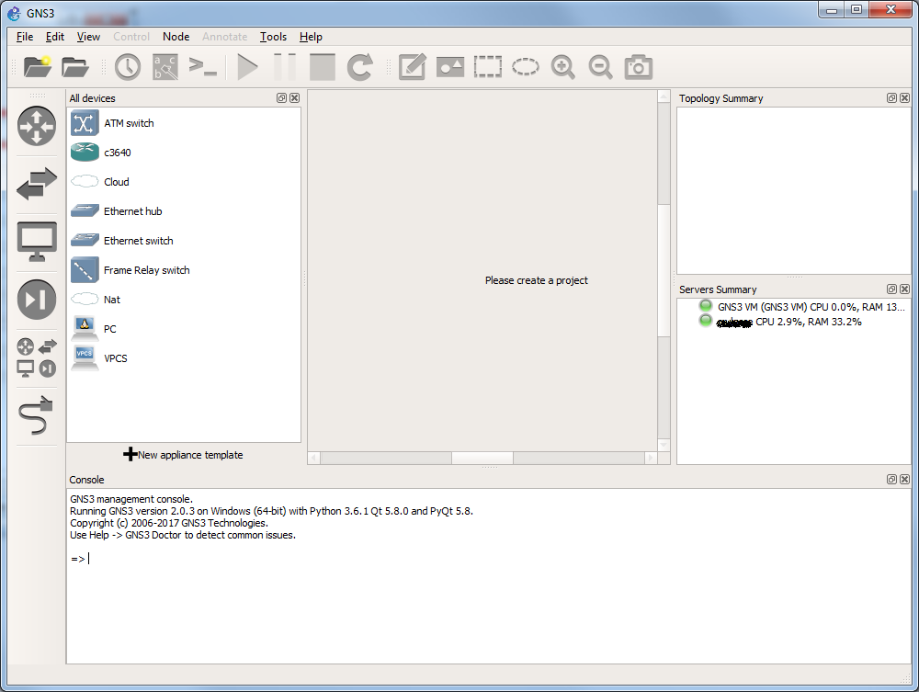

Figure 1.57

1. Create a new project.

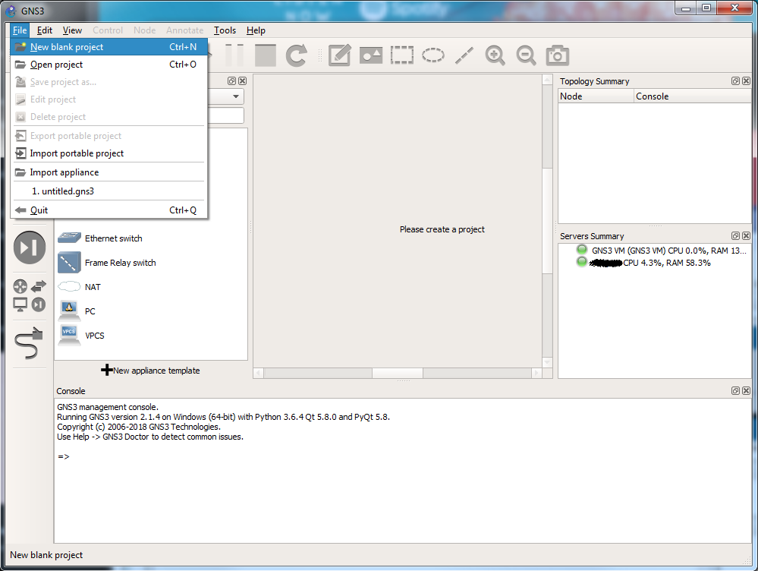

Figure 1.58

1. Give your project a name for example “pcsetup” as shown in Figure 1.59 and Click OK.

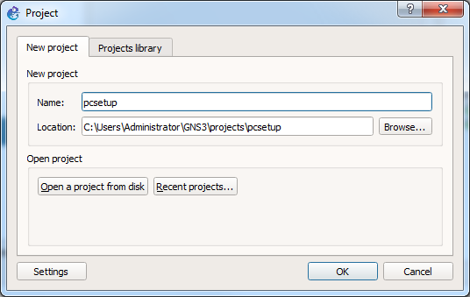

Figure 1.59

1. Expand Browse End Devices and drag and drop PC icon to project window as shown in Figure 1.60. Note: GNS3 automatically numbers all devices.

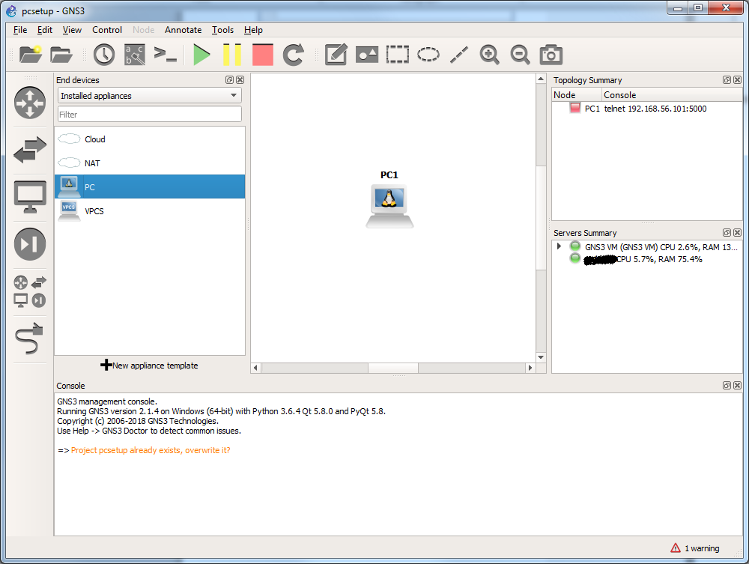

Figure 1.60

1. Start PC-1 as shown below in Figure 1.61. Console screen will scroll with the ipterm setup progress as shown in Figure 1.62.

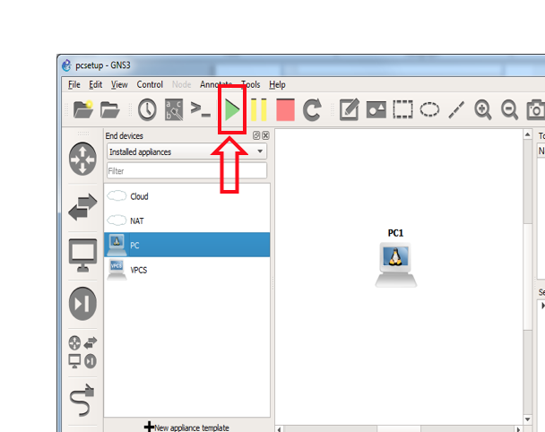

Figure 1.61

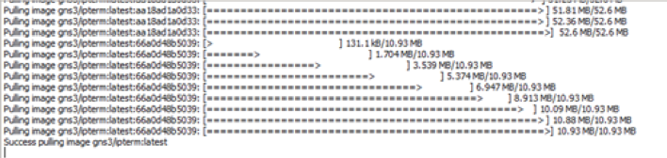

Figure 1.62

1. PC setup is now complete. Stop all devices by clicking on large red button in upper icon bar in GNS3. Quit GNS3

# PART2. Testing the software set up

## In this part we will set up a very simple network configuration to test the installed software components and to make sure all your PCs and GNS3 are working well together.

**Exercise 2(A). Initiation of devices**

1. Open GNS3.
2. Start a new project as explained in Exercise 1(C), step 8. Drag two instances of PC to create PC1 and PC2 in the project pane to start a network simulation as shown in Figure 2.1.

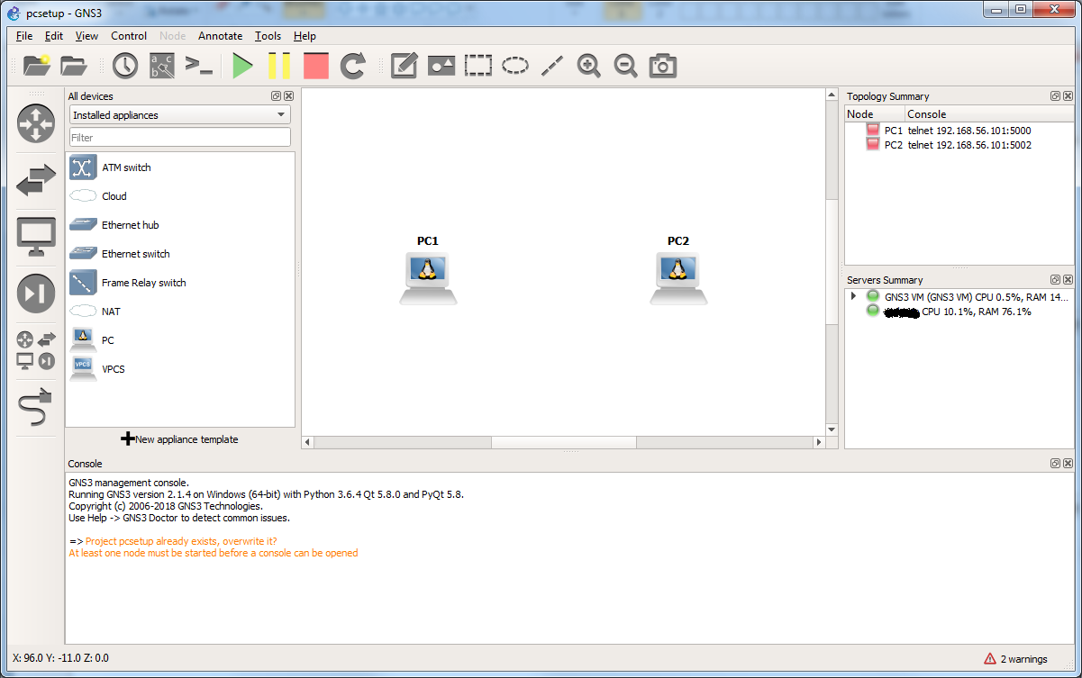

Figure 2.1 PC1 and PC2 in a GNS3 project

1. In GNS3, click on the "Add a link" tab (the 6th icon down on the left-hand side). Note that the 6th icon will change to an icon with an “X” mark (as shown in Figure 2.2 below). Click on PC1 and select eth0 as shown in Figure 2.2. Then repeat the process for PC2. You can press "esc" on your keyboard, or click the 6thicon, to exit the add a link feature.

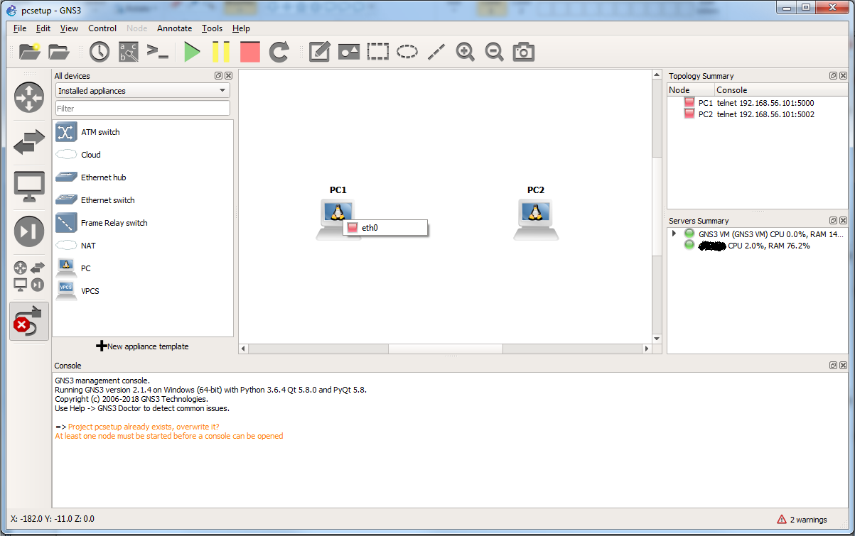

(1)

(2)

(3)

Figure 2.2 How to link two PCs

1. Please note that the color of the dots indicates the status of the devices in GNS3. The red dots indicate that the PCs are not currently active. Now you are ready to test the simulation. Click the "Start/Resume all devices" button (large green arrow) as shown in Figure 2.3.

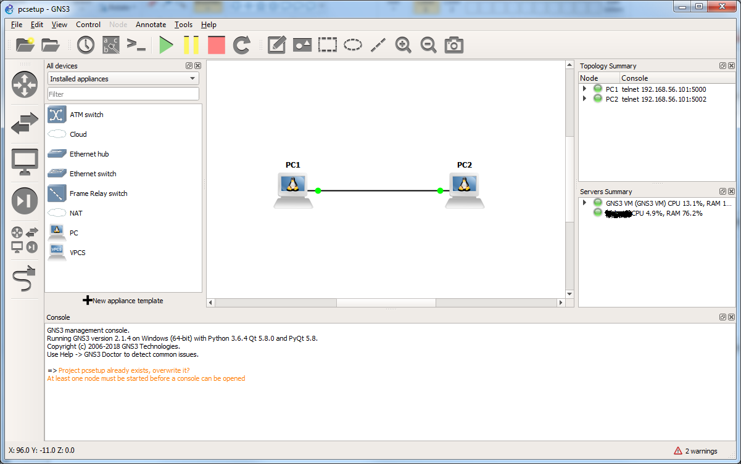

Figure 2.3 Two connected PCs with an active link

1. Click “Console connect all nodes” button to open console windows for each running device in the project panel as shown in Figure 2.4.

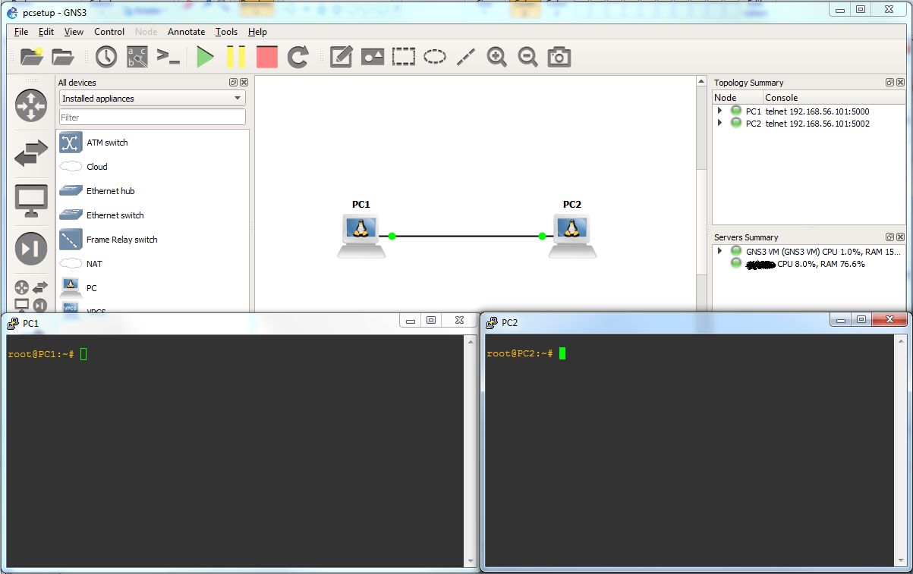

Figure 2.4

## Exercise 2(B). Assigning and manipulating IP addresses

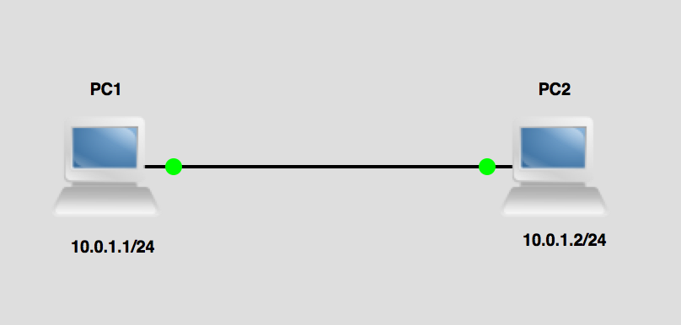

Figure 2.5

To assign an IP address **A.B.C.D/xx** to interface **interface** on a Linux device use the ifconfig command as shown below in the terminal window.

ifconfig **interface A.B.C.D/xx**

Where interface indicates the output port, e.g., eth0, A.B.C.D indicates the IP address, e.g., 10.0.1.4, and /xx indicates the length of the subnet mask, e.g. /24 (255.255.255.0).

1. Assign an IP address on each of PC1 and PC2 with the following command:
2. For PC1: **PC1%** ifconfig eth0 10.0.1.1/24
3. For PC2: **PC2%** ifconfig eth0 10.0.1.2/24

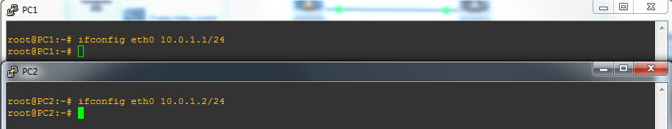

Figure 2.6

1. To check if you have configured the IP address correctly on each PC, type in the terminal window for each PC:

PC1% ifconfig

PC2% ifconfig

1. You should see the following output on their terminal windows

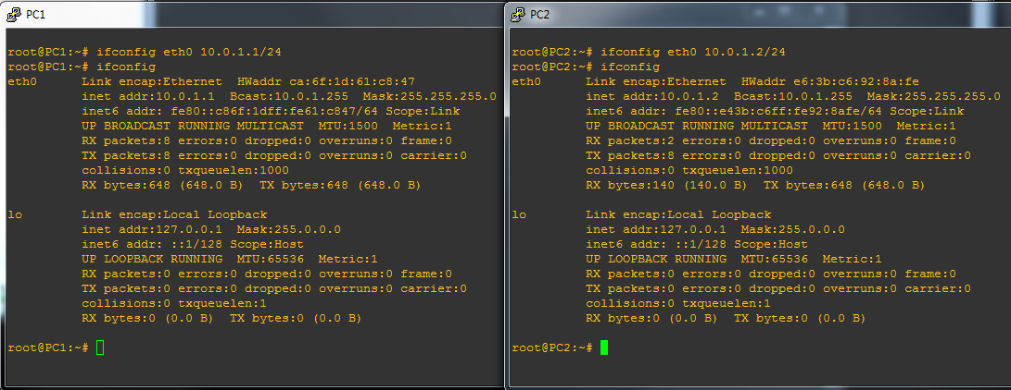

Figure 2.7 ifconfig output

**Exercise 2(C). Using the command Ping**

One of the most basic, but also most effective tools to debug IP networks is the ping command. The ping command tests whether another host or router on the Internet is reachable. The ping command sends an ICMP Echo Request datagram to an interface and expects an ICMP Echo Replay datagram in return. A few ping usage scenarios are listed below.

**COMMON USES OF THE PING COMMAND**

ping **IPaddress**

Issues a ping command for the host with the given IP address. The system will issue one *ICMP Echo Request* packet with a size of 56 bytes every second. The command is stopped by pressing Ctrl-C.

ping **IPaddress** –c **<num>**

The command stops after sending a number, **num**, of *ICMP Echo Requests*.

ping **IPaddress** –s **<num>**

The number of data bytes in the *ICMP Echo Request* is set to **num** bytes.

|  |
| --- |
| **ISSUING PING COMMANDS**  When using ping on the Linux PCs, we recommend to always send at least two ICMP Echo Request packets. We have observed that the first ICMP Echo Request may often be dropped due to the ARP protocol. |

1. From PC1, send five ping messages (using the -c option) to PC2. On PC1, this is done by typing

**PC1%** ping 10.0.1.2 –c 5

1. From PC2, send five ping messages to PC1.

**PC2%** ping 10.0.1.1 –c 5

1. If you did everything correctly, you should see the ping response messages as shown in Figure 2.8.

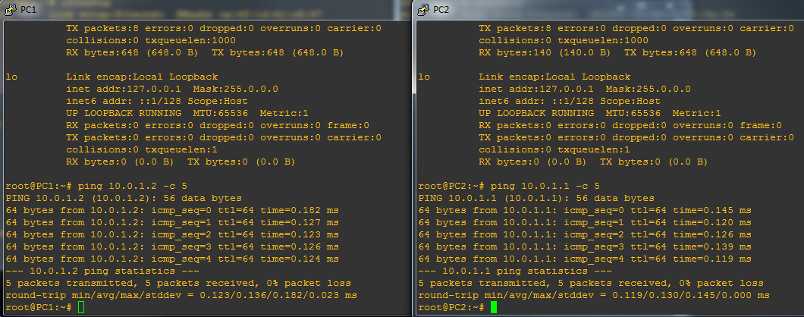

Figure 2.8 Terminal output for ping commands

1. Stop the PCs (red button) and quit GNS3.

1. Login required to download. Create your own personal account. Download appropriate version for your laptop.
2. When done with this lab, download the "GNS3 Getting Started Guide" for future reference. This lab walks you through a simplified installation process.
3. For Mac users, the “create new project window” appears automatically after step 11.
4. Check with Task Manager for Windows, or Activity Monitor for MacOS the cpu % value being used by process “dynamips”.